 **Year 8 - Humanities and Social Sciences 2022**

**Assessment 1 A - Parts A and B (10%)**

**Inquiry Task**

**Consumer Protection Laws**

**Name: _______________________________**

|  |  |  |  |
| --- | --- | --- | --- |
| **Your Target** | **Mark** | **Percentage** | **Weighting** |
| **Inquiry**  **/60**  **Poster**  **/50** | **Inquiry**  **/60**  **Poster**  **/50** |  | **10%** |
| **TOTAL MARKS:**  **/110** | | | |

**Date Due: Week 6, Term 2.**

**Date:_____________________**

Each year since 2006, Choice magazine has asked consumers to nominate goods or services that it considers are shonky products.

The magazine then tests the products and those that meet it’s shonky criteria are shortlisted, from which the ‘winners’ are announced.

The Shonky Awards Hall of Shame can be accessed via <https://www.choice.com.au/shonky-awards/hall-of-shame>.

Students are to select one of the products that has been awarded a Shonky by Choice in the last five years and complete the task below:

**Section One (PART A): Inquiry Process**

Students will investigate if a product has breached the legal rights of consumers, and if so what action the consumer may request.

* Use the inquiry booklet to record information on the legal rights of consumers.
* ****Choose a product that has been awarded a “Shonky Award” by Choice Magazine.
* Investigate and answer questions relating to your chosen product.
* Complete the PMI Chart. *This is to evaluate the task.*
* Complete a bibliography. *The template can be used to assist you.*

**Section Two (PART B): Poster**

Present your research findings as a poster.

**Your poster must include:**

* Name and description of your chosen product (include the year it received the award).
* Explain why the product was chosen to be a recipient of Choice Magazines “Shonky Awards”.
* Describes the legal rights of consumers with regards to purchasing products.
* Explains what actions, if any, consumers who have purchased this product may request from the supplier and/or producer, and why.
* Identifies and describes legal action, if any, consumers of this product undertook.

*Remember to make the poster both creative and informative. Include images of your chosen products.*

**Section Three (Part C): Validation Questions**

*Answer validation questions in relation to your research inquiry. This part will be completed in conjunction with a test in Week 6.*

**Inquiry Process Booklet**

1. **Identify** the organisation that is the governing body of consumer law in Australia. *(2 marks)*

|  |  |
| --- | --- |
| Acronym: ACCC | Full Title: Australian Competition and Consumer Commission |

1. **Explain** the role of this organisation *(5 marks)*

_1 mark per different point of information that explains the role of the ACCC. (5 total. __________________________________________________________________________________________________________________________________________________________________________

1. **Describe** what is meant by the term ‘consumer law’ and why it is important for there to be laws that protect consumers. *(4 marks)*

_______________________________________________________________________________________*2 marks for description of consumer law and 2 marks for why consumer law is important.* _______________________________________________________________________________________________________________________________________________________________________________________________________________________________________________________________

Teacher to tick when completed 

Date:­­

Teacher Initial:

1. **Identify** and **explain** five (5) guarantees that the above organisation provides to consumers *(15 marks)*

|  |  |
| --- | --- |
| **Guarantee** | **Explanation** |
| 1.  1 mark per guarantee | 2 marks for detailed explanation. 1 mark for simple explanation. |
| 2.  1 mark per guarantee | 2 marks for detailed explanation. 1 mark for simple explanation. |
| 3.  1 mark per guarantee | 2 marks for detailed explanation. 1 mark for simple explanation. |
| 4.  1 mark per guarantee | 2 marks for detailed explanation. 1 mark for simple explanation. |
| 5.  1 mark per guarantee | 2 marks for detailed explanation. 1 mark for simple explanation. |

1. **Identify** and **Describe** the three (3) steps in making a consumer complaint to the governing body identified above. *(9 marks)*

|  |  |
| --- | --- |
| **Step** | **Description** |
| **1.**  Contact manufacturer / place of purchase  **(1 mark)** | **1 mark for simple description, 2 marks for detailed.**  *As soon as possible, contact the business to explain the problem and the outcome you want.*  *The business might ask you for*[*proof of purchase*](https://www.accc.gov.au/consumers/prices-receipts/receipts)*and discuss whether it is a minor or major problem to determine a*[*repair, replacement, or refund*](https://www.accc.gov.au/consumers/consumer-rights-guarantees/repair-replace-refund)*.* |
| **2.**  **Contact ACCC (1 mark)** | **1 mark for simple description, 2 marks for detailed.** If *you are still having difficulty resolving a problem, you may want to seek assistance by calling or using their website.* |
| **3.**  **Contact Lawyer (1 mark)** | **1 mark for simple description, 2 marks for detailed.**  *Consider getting independent legal advice about what options are available and suit your circumstances. You may be entitled to take your complaint to the*[*small claims court or tribunal*](https://www.accc.gov.au/contact-us/complaints-enquiries/state-territory-small-claims-tribunals)*in your state or territory.* |

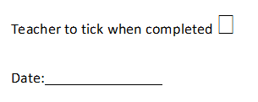

1. **Identify** below the ‘Shonky Award’ winning product you have selected to research, and the year that it was given the award by Choice Magazine.

**____*Name and Year (no marks)_____________________________________________________***

1. **Explain** why your chosen product was the recipient of a ‘Shonky Award’ by Choice Magazine *(4 marks)*

**_______________________________________________________________________________________*1 mark for simple statement that product was faulty. 1 mark for statement explaining why the product was faulty. 2 marks for further explanation and details on how the product was faulty.* ______________________________________________________________________________________________________________________________________________________________________________________________________________________________________________________**

1. **Outline** what legal rights of consumers has been breached by this product. *(3 marks)*

***1 mark for identifying a consumer guarantee that the product has breached. 1 mark for outlining this. 1 mark for detail and example of how it breaches consumer legal rights.* __________________________________________________________________________________**

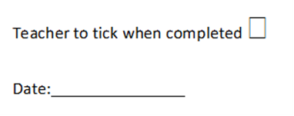

1. **Explain** what actions, if any, consumers who have purchased this product may request from the supplier and/or producer, and why. *(3 marks)*

**___________________________________________________________________________________*1 mark for per point of how the consumer can make a complaint. (3 steps from question 5 above related to the product. Ie. Specific information Can contact Samsung.* ________________________________________________________________________________________________________________________________________________________________________________________________________________________________________________________**

1. **Identify** and **describe** legal action, if any, consumers who have purchased this product have entered against the producer. *(3 marks)*

***___________________________________________________________________________________1 mark for identifying if any legal action has been taken against the producer, or manufacturer / if any laws are being discussed or being called to change.***

***2 marks for providing description* ___________________________________________________________________________________________________________________________________________________________________________**

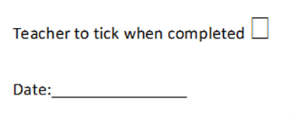

1. **Complete the PMI chart below**

|  |  |  |
| --- | --- | --- |
| P – Plus | M - Minus | I - Interesting |
| Positives (Pluses) about the task Consumer Law | Negatives (Minuses) about the task or Consumer Law | Interesting parts about the task or Consumer Law |
|  |  |  |

Teacher to tick when completed 

Date:­­

Teacher Initial:

|  |  |  |  |  |  |
| --- | --- | --- | --- | --- | --- |
| **Author** | **Date last updated** | **Title of Webpage** | **Date accessed** | **HTTP** | |
|  |  |  |  |  | |
|  |  |  |  |  | |
|  |  |  |  |  | |
|  |  |  |  |  | |
|  |  |  |  |  | |
|  |  |  |  |  | |
| **Author** | **Date of Publication** | **Title of Book** | **Publisher** | | **Place of Publication** |
|  |  |  |  | |  |
|  |  |  |  | |  |
|  |  |  |  | |  |

1. **Reference recording sheet**

*Please note that in order to obtain full marks you must submit a formal bibliography, the table below is only for recording your references as you are researching.*

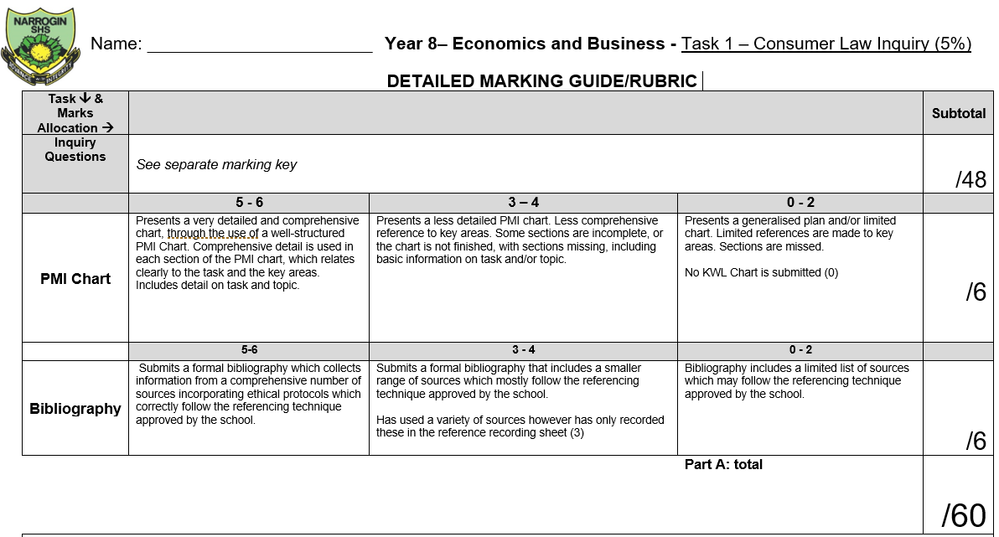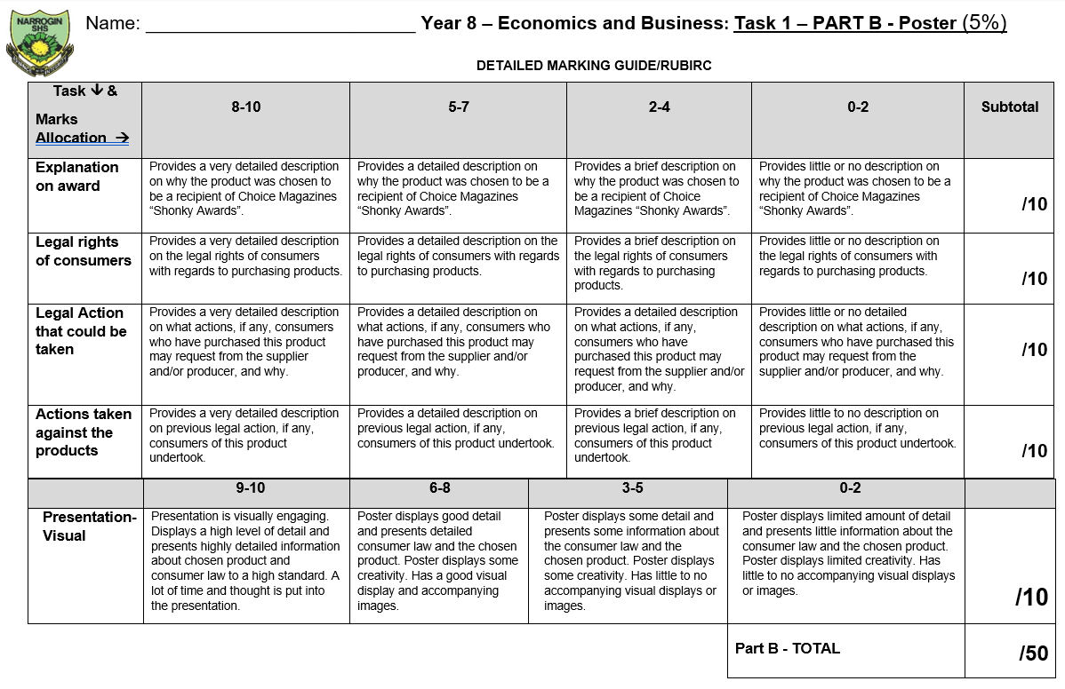

**Feedback:**